**SETUP GOOGLE CLOUD PLATFORM WITH JUPYTER (MALAYSIA)**

1. Create a free account in Google Cloud Platform (GCP). Google Cloud will free you 300 credit after you created the account successfully.

@Google Cloud Platform 
Google Cloud Platform Free Tier 
Learn and build on GCP for free. 

Google Cloud Platform 
Manage resources 
Filter by name, ID, project number or label 
You have no projects in this organisation. 
Resources pending deletion 
a CREATE PROJECT 
i DELETE 

\*\*Note that GCP is accepting debit card and credit card.

1. Create a new project, note that the project is linked to your google account is linked to your google account, so it is recommended to always remove your unused project.

Google Cloud Platform 
Billing 
Overview 
Budgets & alerts 
Transactions 
Billing export 
Payment settings 
P ayment method 
Overview 
Billing aCCOW1t 
Billing account 
Credits 
My Billing Account 
Payment 
$300.00 
Credits remaining 
Out of 900.00 
RENAME BILLING ACCOUNT 
365 
Days remaining 
Ends Jan 19, 2019 
projects linked to this billing account 
Project name Project ID 
tfml.19261S 

1. Setting up the compute engine and create a VM instance.
2. Create new instance
3. Name your instance
4. Select region as “asia-southeast1 (Singapore)” and zone as “asia-southeast1-b”
5. Machine type as “8 vCPUs” and 30GB memory, CPU platform as “automatic” and 1 NVIDIA Tesla P4 GPU
6. Select boot disk as “ubuntu 16.04 LTS” and boot disk type as “10 GB SSD persistent disk”, the default boot disk type is HDD, but the price actually doesn’t change much, so just choose a SSD.
7. Tick both “http” and “https” under firewall options.
8. To access the Jupyter network, we need to make the external IP address static. By default, the IP address is dynamic, and we need to make it to static to make our life easier. Click on the three horizontal lines on top left and then under networking, click on VPC network and then external IP address.

Targets 
All instances in the network 
Source filter 
IP ranges 
Source IP ranges 
0.0.0_0/0 0 
Second source filter 
None 
Protocols and ports 
Allow all 
• Specified protocols and ports 
tcp 9000 
Disable rule 
Save 
Cancel 

1. Start the VM instance and click “SSH” to open the command window.

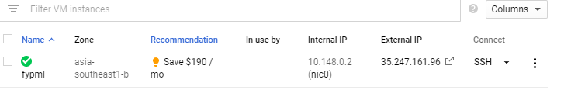

1. In your SSH terminal:
2. wget <http://repo.continuum.io/archive/Anaconda3-4.0.0-Linux-x86_64.sh>
3. bash Anaconda3-4.0.0-Linux-x86\_64.sh
4. ***Do you wish the installer to prepend the Anaconda3 install location to PATH in your /home/haroldsoh/.bashrc?*** yes
5. source ~/.bashrc
6. pip install tensorflow
7. pip install keras
8. Setup the VM server:
9. Check if you have a Jupyter configuration file by “ls ~/.jupyter/jupyter\_notebook\_config.py” and if it does not exist, create one by “jupyter notebook --generate-config”
10. Add few lines to the Jupyter configuration file:

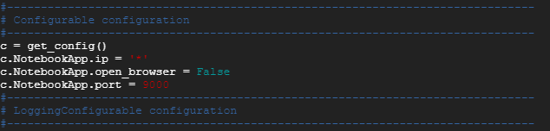

1. To launch Jupyter Notebook, type the command “jupyter-notebook --no-browser --port=9000”

in SSH window.



Then type the following in your browser,

<http://35.247.161.96:9000/>

